- Two papers have recently been published that contradict each other. In one paper, the authors found no evidence of ongoing neurogenesis in the adult human hippocampus and that any proliferating cells in the hippocampus seem to cease producing neurons early in life. In a second, paper, the authors do find evidence of ongoing neurogenesis, even in elderly humans in the same area. Both papers used similar techniques, but arrived at conflicting conclusions. Pretend that we have no regards for ethics or the value of human life. Construct an experiment that provides strong evidence of functional neurogenesis in the adult human hippocampus (in other words, show that newborn cells in the hippocampus are functioning neurons or that neurogenesis is needed for some behavioral aspect). Make sure you clearly state your parameters and expected outcomes for the experiment. (25 pts.)
Papers for reference:
Sorrells et al. (2018) Human hippocampal neurogenesis drops sharply in children to undetectable levels in adults. Nature. 555: 377-81.
Moreno-Jiménez et al. (2019) Adult hippocampal neurogenesis is abundant in neurologically healthy subjects and drops sharply in patients with Alzheimer’s disease. Nat Med. 25: 554-560.

- A grad student was testing whether motor neurons have intrinsically (epigenetic) or extrinsically (environmental) determined fates. They took motor neurons from the anterior spinal cord (cervical level of the vertebrae) of a mouse embryo and transplanted them to the primary motor cortex of a postnatal mouse pup. They found that the transplanted motor neurons did not innervate muscles in the arm like they did in their normal environment. The grad student then surmised that these motor neurons fates and connectivity are defined by environmental rather than an intrinsic epigenetic factors.
  - While this transplant experiment may not be the best, was the grad student correct in their conclusions? Explain. (10 pts.)
  - Construct a better transplant experiment than the one performed by the grad student that would give better evidence for or against their original conclusion. (25 pts.)

- In a mutagenic screen, a postdoc found that knocking out a fly gene caused developing axons to not respond to many common guidance cues like netrins, BDNF, etc. Because these axons seem to grow randomly and roam throughout the fly embryo, she named the gene Zombie. One such example of failure to respond to axon guidance cues was Netrin, a common attractant for dorsal commissural neurons. When wild type neurons are exposed to a netrin gradient, they growth cone responds by turning in the direction of the netrin source. Zombie knock outs do not seem to respond to any source of netrin. See below:
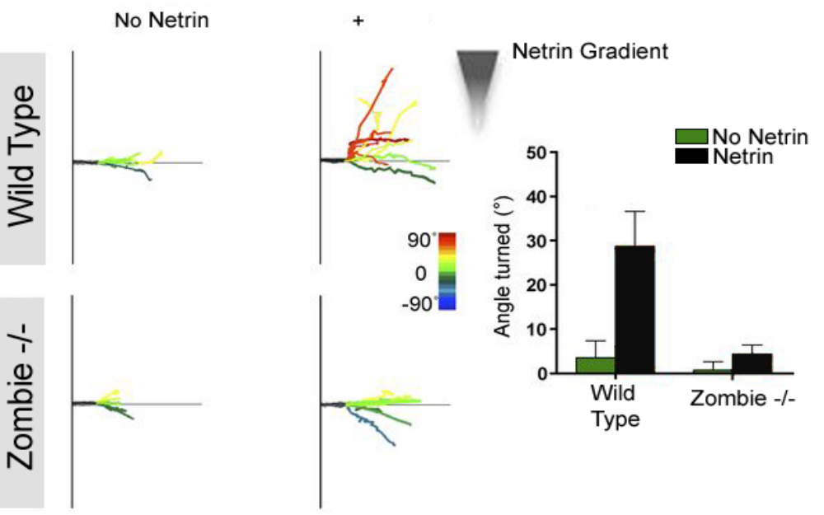

  - In her haste, the postdoc never verified where in the genome the zombie mutation was located. Meaning, she has no idea if this is a new gene. Based on the information above, is it likely that the mutated Zombie gene is a netrin receptor? Why or why not? (10 pts.)
  - The postdoc’s PI suggested that the Zombie gene product may be involved in protein translation of local actin that helps the growth cone alter course when presented with a new guidance cue. The postdoc thinks that the Zombie protein helps traffic receptors for guidance cues to the membrane of the growth cone. Design an experiment that either confirms or disproves one of these positions. (20 pts.)

- During development, many dividing neural stem cells are slated to die. In fact, many of the TUNEL (Terminal transferase UTP Nick End Labeling) positive cells in proliferative areas are also positive for thymidine analogs like BrdU, suggesting that cells start dying sometime during S or G2 phase of the cell cycle. Since we know that entering the cell cycle and mitosis is a very large energetic undertaking, why do cells expend so much time and energy to proliferate if they are just going to die? In your own words, explain what is going on here. (10 pts.)

